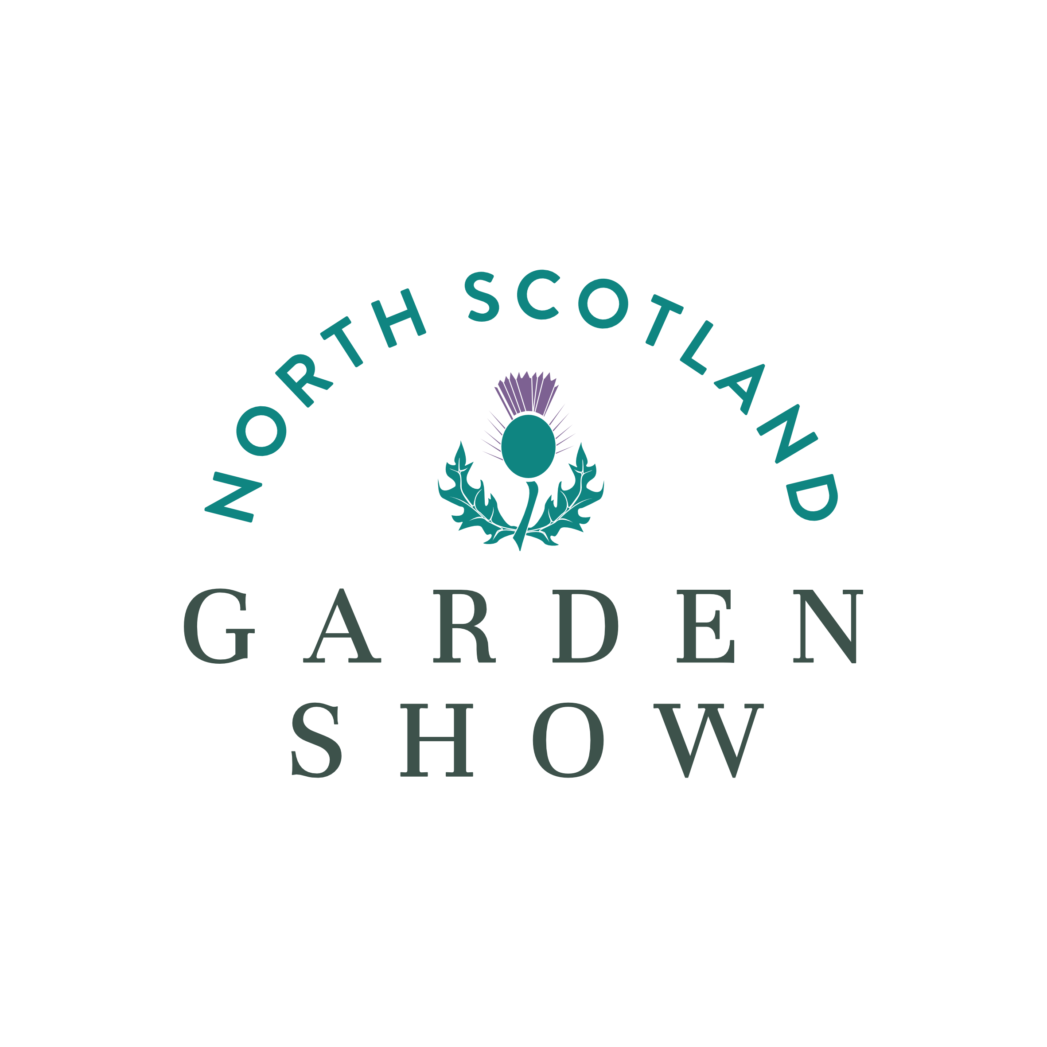
Pallet Garden Challenge Entry Form for the North Scotland Garden Show (NSGS) 2026

Friday 12th June 1000 to 1900 & 13th June 1000 to 1600

We would like to take part in the NSGS Pallet Garden Challenge 2026

Number of A 195 x 95 x 15 pallet collars entering _________________

Number of B 74 x 54 x 15 pallet collars entering _________________

Number of C 115 x 75 x 15 pallet collars entering

Name of organisation _______________________________________

Name & address of contact person _______________________________________

____________________________________________________________________

____________________________________________________________________

Please state how we can keep in touch with you (required)

Daytime Phone Number _______________________________

Evening Phone Number ________________________________

Email address ________________________________________

Please submit your application by email to info@nsgardenshow.com

Or by post to
North Scotland Garden Show
Easterton Kennels
Drummuir
Keith
AB55 5JJ

Please register your interest as soon as possible. Closing date 1st March 2026

